**Lab 03**

Calculate and measure all values of the resistances, current, voltage and find the total current /voltage across all resistances for the given circuit s

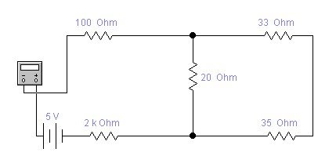

# Apparatus

* Resistors
* Multi-meter
* Jumper Wires
* Breadboard
* DC Supply

# Procedure

* We took 5 resistors and noted their values after confirmation by color code and multimeter measurements.
* Constructed a circuit of these resistors as shown below.



* Calculated the equivalent resistance using formula
* Checked the resistance of the series combination by connecting the multimeter probes at points A and B.
* Connected a measured voltage between points A and B and noted the current flowing through the circuit.The circuit diagram is depicted below:

**Verification:**

**Individual resistance values:**

|  |  |  |  |
| --- | --- | --- | --- |
| **Resistor symbol** | **Value (****)** |  | **Value to be used in calculation**  **(****)** |
|  | **Color Code** | **Multimeter** |  |
|  |  |  |  |
| **R1** |  |  |  |
| **R2** |  |  |  |
| **R3** |  |  |  |
| **R4** |  |  |  |
| **R5** |  |  |  |

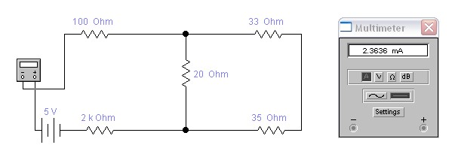

|  |  |  |  |  |  |
| --- | --- | --- | --- | --- | --- |
| **S.**  **No.** | **Total Resistance Value (****)** | | **Applied Voltage**  **(V)** | **Current**  **(A)** | **Resistance value (V/I)**  **(****)** |
| **Calculated using formula** | **Measured with multimeter** |
|  |  |  |  |  |  |
|  |  |  |  |  |  |